//Expt 1

Symbol Table

import java.io.\*;

import java.lang.\*;

class SymbolTable

{

public static void main(String args[]) throws Exception

{

FileReader fr = new FileReader("program.asm");

BufferedReader br = new BufferedReader(fr);

String s,l;

String code[]=new String[100];

String label[]=new String[100];

int N=0,i,LOC=0,n=0,j;

System.out.println("Assembly lang program :\n--------------------------");

while((s = br.readLine()) != null)

{

code[N++]=s;

System.out.println(s);

}

fr.close();

FileReader labels = new FileReader("label.txt");

BufferedReader buff = new BufferedReader(labels);

while((s = buff.readLine()) != null)

{

label[n++]=s;

}

labels.close();

System.out.println("\n\n SYMBOL TABLE :\n-------------------------------------------\nLABEL\tLC\tLENGTH\tRELATIVE/ABSOLUTE\n-------------------------------------------");

for(i=0;i<N;i++)

{

for(j=0;j<n;j++)

{

char codearr[]=new char[15];

codearr=code[i].toCharArray();

if(code[i].startsWith("USING"))

{

break;

}

else if(code[i].startsWith(label[j]))

{

System.out.println(label[j]+"\t"+LOC+"\t4\tR");

if(i==0)

{}

else

LOC=LOC+4;

break;

}

else if(codearr[1]=='R') // for register addressing mode

LOC=LOC+2;

else

LOC=LOC+4;

}

}

}

}

/\* OUTPUT

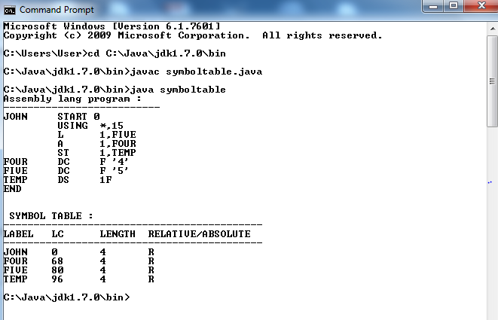

\*/

program.asm

JOHN START

USING \*,15

L 1,FIVE

A 1,FOUR

ST 1,TEMP

FOUR DC F '4'

FIVE DC F '5'

TEMP DS 1F

END

label.txt

JOHN

FOUR

FIVE

TEMP